

ASSIGNMENT COVER SHEET

Student Name: Darren Cosgrave (B00067349) Chris O Gara (B00071897)

Course: BN013 BSC in Computing

Year: 2015 year 3 out of 3

Lecturer: Orla McMahon

Title of Assignment: Rich Web Applications: Assignment 2 (30%)

Due Date: Sunday, 6th December 2015, 11:55 PM

Date Submitted: Sunday, 6th December 2015, 8:00 PM

The material contained in this assignment is the author’s original work, except where work quoted is duly acknowledged in the text. No aspect of this assignment has been previously submitted for assessment in any other unit or course.

Signed: _______________________________ Date: ______/______/______

Signed: _______________________________ Date: ______/______/______

# Abstract

For our assignment two we have decided and have agreed to use Darren’s web assignment one, made for he’s aunty who is trying to set up a new beauty salon. We will improve the assignment 1 to be used for our assignment 2. We are working in a group of two with myself Darren Cosgrave and fellow student Chris O Gara. We plan to break up the work load evenly between us

Table of contents

Abstract 2

Working Application 4

Facebook or Twitter 4

Blog 4

Icon 5

Workload 5

Darren 5

Chris 5

What we learned 5

Research 6

# Working Application

## Facebook or Twitter

Here you can see that we have the Twitter and Facebook link and like for the web site, so when you click on either one of them it will bring you to the websites Facebook or Twitter page.



## Blog

Here you can see that we have a blog setup for users to ask questions leave recommendations or just to chat and share beauty tips on the websites blog.

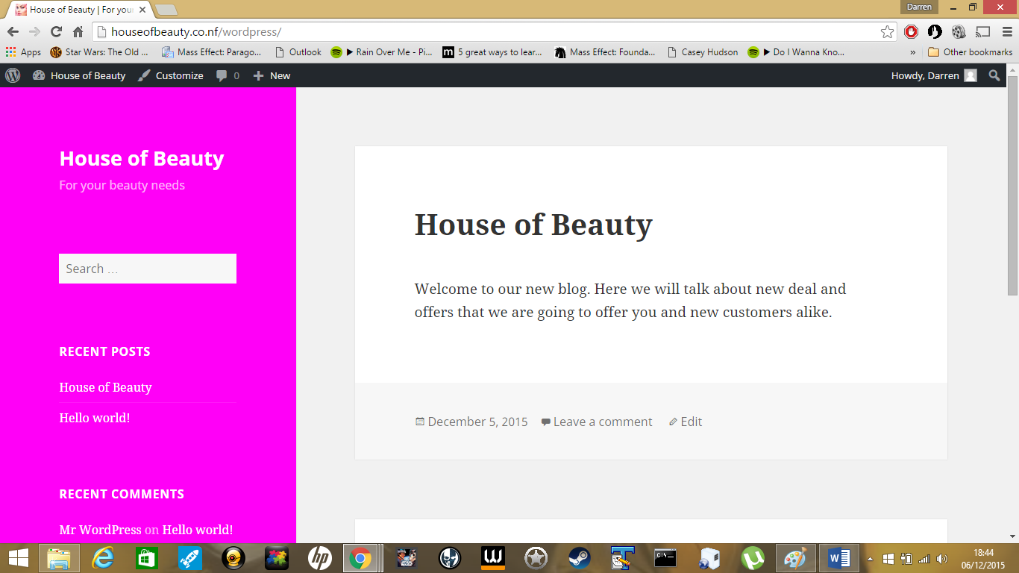

## 

## Icon

In the image below you can see the websites icon and showing that it is hosted online.

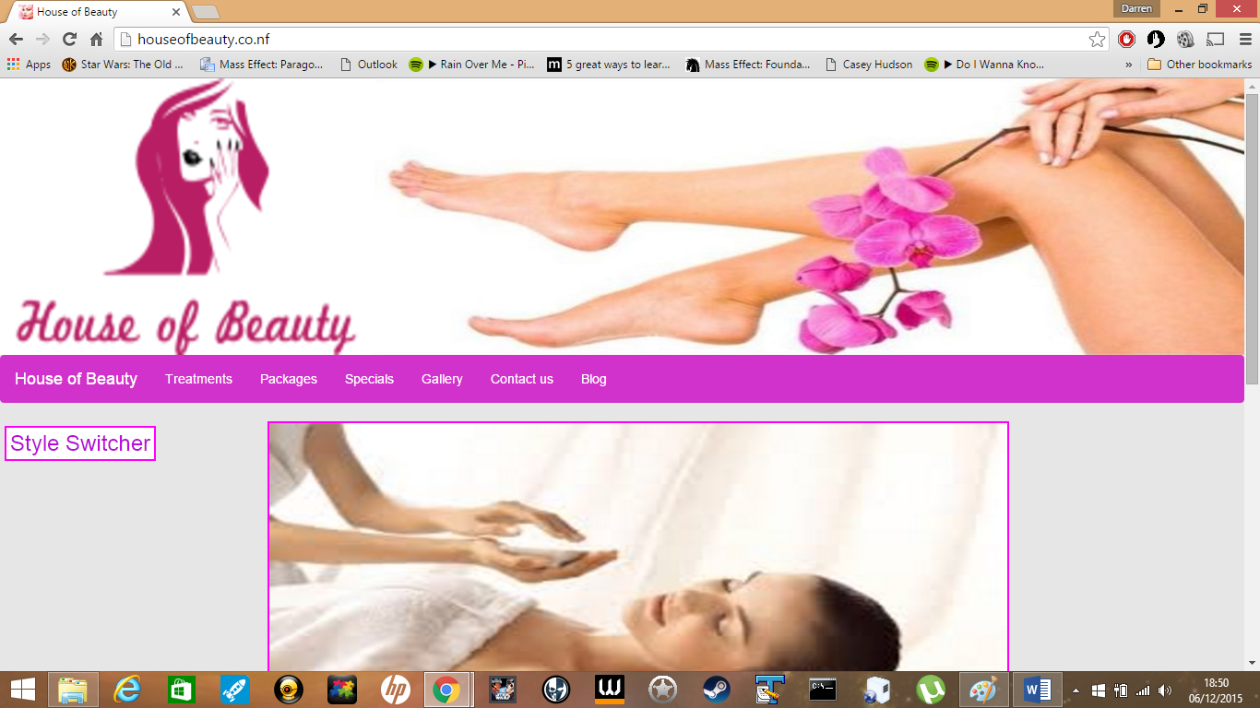

# Workload

## Darren

Has hosted the website online and available to see at the following link stated here (<http://houseofbeauty.co.nf/>).

Set up the icon for the website.

Set up the google map, bar the directions.

Got WordPress to work on the hosted site.

## Chris

Has worked on the Twitter and Facebook link and like for the web site.

Has done the research section of the report.

# What we learned

We have learned how to go about looking for a free hosting services that is good and that gives us what we need to make this assignment two to work for us and that also give us as much free memory to work around with and to test out new JQuery technologies. We now know how to set up and host a website thanks to a few YouTube tutorials.

We can set up the Twitter and Facebook link and like with ease.

Thanks to a few YouTube tutorials we now know how to set up WordPress on the hosting service and have also learned how use WordPress.

# Research

Frameworks are a huge part of web development. They assist in the development of web applications and increase productivity with the use of a code libraries. These libraries can be used for database access, templating frameworks and session management.

Hugely popular frameworks available at the moment are Django, Bootstrap, Flask, Yii and JQuery Mobile among many others. Django is a Python framework that is known for its huge library and fast response time.

Bootstrap is a design framework. Flask is another Python framework and Yii is PHP framework. For our website we used the JQuery Mobile framework to do optimize our website to work with mobile devices.

It has great features such as the themerollar that is great for web design. It also has great cross platforming support for different devices. However, there are many more frameworks on the market that we could have used to develop our web application.

I will be looking at an alternative and how we could have implemented its features. One framework I found that looked like a good alternative was jQWidgets. JQWidgets is a comprehensive framework based on JQuery for building professional web applications and mobile applications.

The framework works with JavaScript, html5 and jQuery. It also has over 60 powerful widgets and is one of the fastest growing UI frameworks on the web. For mobile devices, jQWidgets detects the device type and browser to adjust itself for the users experience and it supports all major mobile web browsers such as Internet Explorer 7.0, Firefox 2.0, Safari 3.0 and more.

This mobile optimisation is essential as you need your web application to look smooth on all devices. Sometimes JQuery widgets don’t integrate well with each other or lack features, but widgets on jQWidgets integrate seamlessly together respond well on all devices and browsers.

Some frameworks are just modified versions of the JQuery UI Toolkit but the widgets that jQWidgets provides are original and even provide widgets extensions, settings, internal event handling and routing.

The widgets they provide have a lot more unique features than JQuery does not have. JQWidgets comes with multiple built-in cross-browser themes to make every widget and web page look consistent.

They also come with keyboard support, built in WAI-ARIA support and a high contrast theme to help users with visual disabilities. For help optimising mobile devices, jQWidgets provide a mobile application with tutorials to help make your web application look great on all devices.

JQWidgets is a tested framework with huge companies using the framework such as HP, Nvidia and Ericsson. It has a number of useful components that could be used for out web application. These are components such as jqxScrollView, jpxListMenu and jpxScroll bar.

JpxScrollView is a widget used for content sliding. This would have looked good on our gallery section for our images instead of the image selector. Content sliding is a modern way of showing images and is seen of a lot of professional websites. JpxListMenu is a widget for making nested lists.

These nested lists could have been used on our treatment page under each heading. Having the individual treatments information bullet pointed stands out more and is easier for the user to read.

JpxScrollBar is a scroll bar widget used for making normal scroll bars into more creative and smooth looking ones. This would have been great for the whole web application as the normal scrollbar gets very repetitive to look at. Conclusion to research.

As you can see, there are various framework options for a developer of web applications. They help a huge amount in the process of developing an application and save you a lot of time. JQWidgets had some useful features which JQuery did not provide such as visual disability support. Looking at both JQuery and jQWidgets frameworks, they seem essential to produce a professional looking website.t